**1. Write a Python program to find the number of times 4 appears in the tuple.**

**Input: tuplex = (2, 4, 5, 6, 2, 3, 4, 4, 7 )**

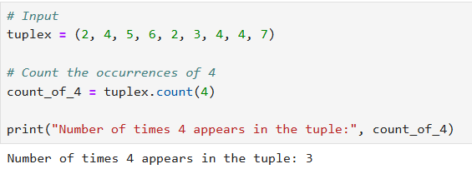

**2.Write a Python program to convert a list to a tuple.**

**Input: listx = [5, 10, 7, 4, 15, 3]**

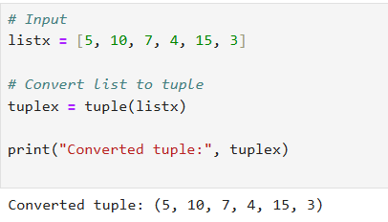

**3. Write a Python program to calculate the sum of the numbers in a given tuple.**

**Input: tuples_list = [(1, 2), (3, 4), (5, 6)]**

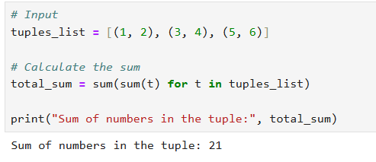

**4.Write a python program and iterate the given tuples**

**Input: employee1 = ("John Doe", 101, "Human Resources", 60000)**

**employee2 = ("Alice Smith", 102, "Marketing", 55000)**

**employee3 = ("Bob Johnson", 103, "Engineering", 75000)**

